**Artificial Intelligence and Machine Learning**

**LAB 3**

**Name: PUNEETH L**

**USN: 1BM24MC069**

**3. For a dataset, apply Apriori algorithm and identify the best rules based on support and confidence.**

Program:

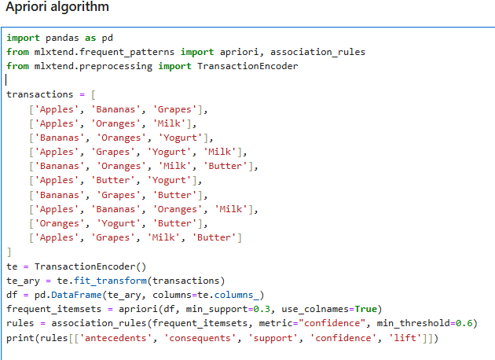

Output:

